
Symbiosis Institute of Technology, Pune
Faculty of Engineering
CSE- Academic Year 2026-27
Java Programming – Lab Batch 2024-28
Lab Assignment No: - 25
Name of Student: Sanika Botre
PRN No.: 25070122063
Batch: 2025-29
Class: CSE A-2
Academic Year & Semester: 2026 & 3rd Semester
Date of Submission
Title of Assignment: Write a Java program using the Thread class to create multiple threads and demonstrate their lifecycle.
Learning Objectives: To create and manage multiple threads using the Thread class.

Theory:
A thread is the smallest unit of execution within a Java program. Multithreading enables multiple tasks to execute concurrently, improving application performance and responsiveness. Java provides the Thread class for creating threads by extending it and overriding the run() method. A thread passes through different lifecycle stages including New, Runnable, Running, Blocked/Waiting, and Terminated. The scheduler manages thread execution based on system resources. Methods such as start(), sleep(), join(), and interrupt() control thread behavior. Multithreading is commonly used in games, web servers, animation, and background processing applications.
Practice questions
1. Create a program where multiple threads print numbers simultaneously
Code:
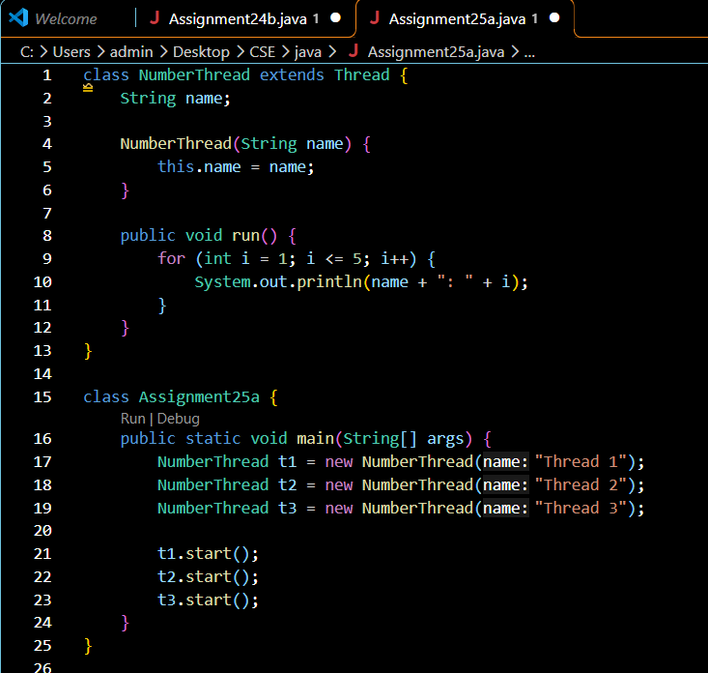
Output:
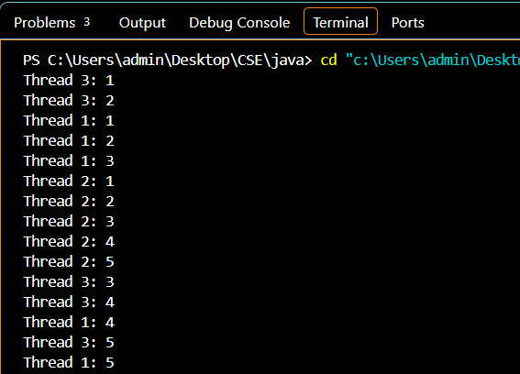
2. Create a Java program using multiple threads to simulate bank transactions. One thread performs deposit operations, and another performs withdrawal operations, both printing transaction details simultaneously
Code:
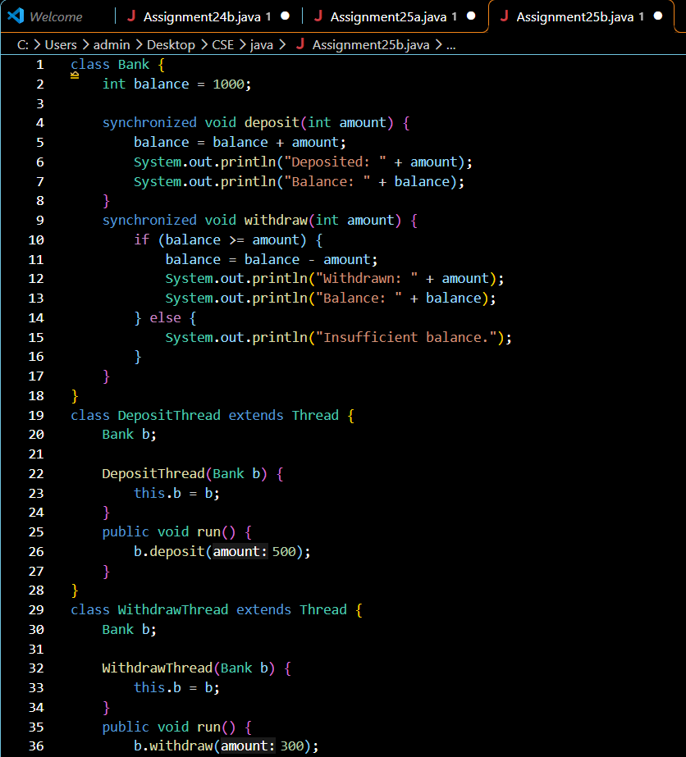
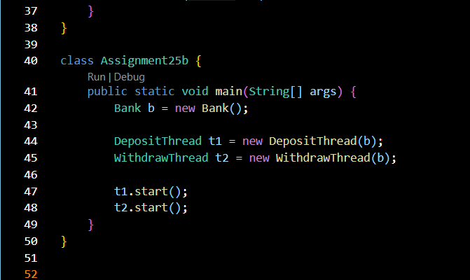

Output:
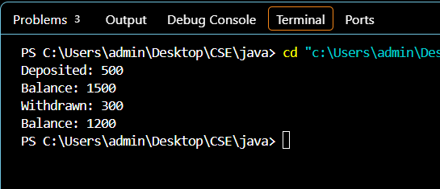

Conclusion
Thus, both programs were successfully implemented using the Thread class in Java. The first program demonstrates multiple threads printing numbers simultaneously, while the second simulates bank deposit and withdrawal transactions. The use of synchronization ensures safe access to the shared bank balance and maintains correct transaction results.

